|  |  |
| --- | --- |
| **Ex. No. 5** | **JAVASCRIPT – DOM ELEMENTS AND EVENTS** |
| **Date of Exercise** | 22-8-2022 |
| **Web Host Link** |  |
| **YouTube Link** |  |

**Aim:**

To create a web pages demonstrating the applications of document object model and events in JavaScript.

**Description:**

**Document Object Model:**

A Document object represents the HTML document displayed in that window. The Document object has various properties that refer to other objects which allow access to and modification of document content. The way documented content is accessed and modified is called the Document Object Model, or DOM.

**Finding HTML Element:**

var myElement = document.getElementById("intro");

Finding HTML Elements by Tag Name

var x = document.getElementsByTagName("p");

Finding HTML Elements by Class Name

var x = document.getElementsByClassName("intro");

Finding HTML Elements by CSS Selectors

var x = document.querySelectorAll("p.intro");

Attach event handler to the document

document.addEventListener("click", function()

{  
  document.getElementById("demo").innerHTML = "Karunya";  
});

**JavaScript Events:**

JavaScript's interaction with HTML is handled through events that occur when the user or the browser manipulates a page.

|  |  |
| --- | --- |
| **Event** | **Description** |
| Onabort | Triggers on an abort event |
| Onblur | Triggers when the window loses focus |
| Onchange | Triggers when an element changes |
| Onclick | Triggers on a mouse click |
| Ondblclick | Triggers on a mouse double-click |
| Ondrag | Triggers when an element is dragged |
| Onfocus | Triggers when the window gets focus |
| Onkeyup | Triggers when a key is released |
| Onload | Triggers when the document loads |
| Onkeydown | Triggers when a key is pressed |
| Onkeypress | Triggers when a key is pressed and released |
| Onmousedown | Triggers when a mouse button is pressed |
| Onmousemove | Triggers when the mouse pointer moves |
| Onmouseout | Triggers when the mouse pointer moves out of an element |
| Onmouseover | Triggers when the mouse pointer moves over an element |
| Onmouseup | Triggers when a mouse button is released |
| Onmousedown | Triggers when a mouse button is pressed |
| Onresize | Triggers when the window is resized |
| Onscroll | Triggers when an element's scrollbar is being scrolled |
| Onresize | Triggers when the window is resized |
| Onscroll | Triggers when an element's scrollbar is being scrolled |
| Onsubmit | Triggers when a form is submitted |
| Onunload | Triggers when the user leaves the document |

# Program:

1. Write a function that accepts a string as a parameter and find the shortest and longest word within the string.

**Code:**

<!DOCTYPE html>

<html>

    <head>

        <title>string</title>

    </head>

    <body>

        <script>

            function big_small()

            {

                len = str1.length

                const arr = str1.split(' ');

                arr.sort((a,b) => a.length - b.length);

                len = arr.length

                document.write("Shortest : "+ arr[0]);

                document.write("Longest : "+ arr[len-1]);

            }

            var str1 = prompt("Enter a string : ");

            var smallest = big_small(str1);

        </script>

    </body>

</html>

**Output:**

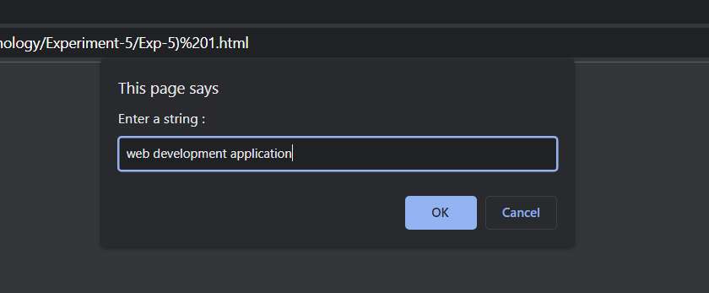

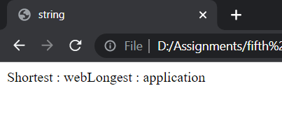

2.Design a BMI calculator

**Code:**

<!DOCTYPE html>

<html>

    <head>

        <title>BMI calculator</title>

    </head>

    <body>

        <hl><b>Calculate your body index</b></hl>

        <fieldset>

            Weight(in kilograms): <input type="text" id="weight"><br><br>

            Height(in meters): <input type="text" id="height"><br><br>

            <button type ="submit" onclick="calculate()">Get BMI </button>

        </fieldset>

    <p> Your BMI is <u><b><span id = "score1"></span></b></u><br>

        Your body type is <u><b><span id = "type1"></span></b></u>

    </p>

    <script language="JavaScript">

        function calculate()

        {

            var weight = parseFloat(document.getElementById("weight").value);

            var height = parseFloat(document.getElementById("height").value);

            const score = weight/(height*height)

            document.getElementById("score1").innerHTML = score;

            var type;

            if(score < 18)

            {

                type = "Underweight";

            }

            else if(score > 18 && score < 25)

            {

                type = "Normal";

            }

            else if(score > 25 && score < 30)

            {

                type = "Overweight";

            }

            else

            {

                type = "Obese";

            }

            document.getElementById("type1").innerHTML = type;

        }

    </script>

    </body>

</html>

**Output:**

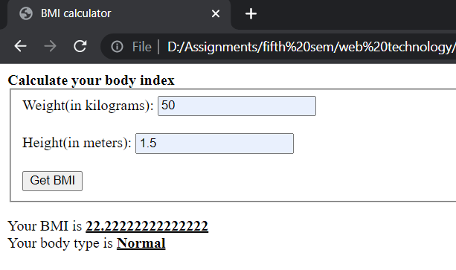

3. Fruit Farm: When you click the “Plant Garden” button, the page should generate a rectangular grid of fruit images in the div with the id of “garden.” The dimensions of grid are given by the values entered in the text boxes.

**Code:**

<!DOCTYPE html>

<html>

    <head>

        <title>Fruit Farm</title>

    </head>

    <body>

        <h1><b>Fruit Farm</b></h1>

        <div>

            Rows:<input type="text" id="row">

            Colums:<input type="text" id="column">

            <button type="button" onclick="grow()">Plant Garden</button>

        </div>

        <p id="garden"></p>

        <script>

            function grow()

            {

            var Rows = parseInt(document.getElementById("row").value);

            var Colums = parseInt(document.getElementById("column").value);

            var arr = ["orange.jpg","apple.jpg"];

            var Name = arr[Math.floor(Math.random() * arr.length)];

            for (let i =0; i<Rows; i++)

            {

                for(let j = 0; j<Colums; j++)

                {

                    var arr = ["orange.jpg","apple.jpg"];

                    var Name = arr[Math.floor(Math.random() * arr.length)];

                    string = document.getElementById("garden").innerHTML +="<img src="+Name+" width=100px height=100px>";

                }

            garden.innerHTML += "<br>";

            }

            }

        </script>

    </body>

</html>

**Output:**

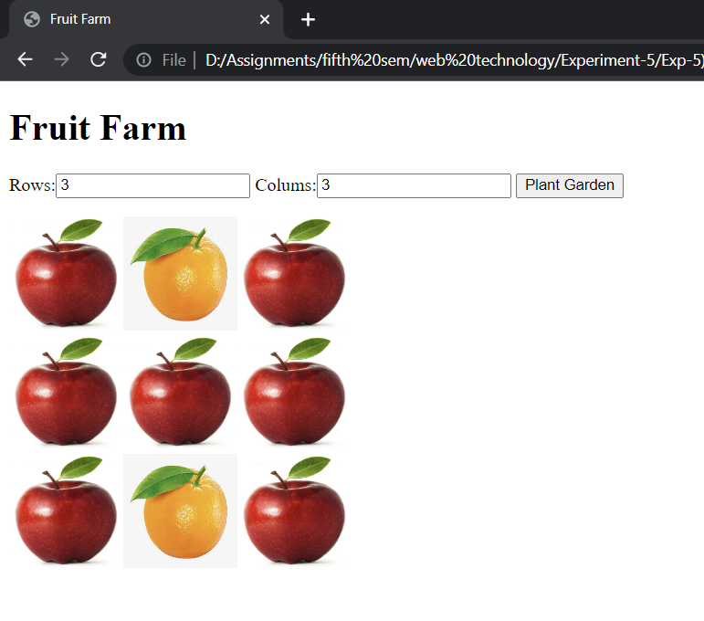

4. Currency convertor from USD to INR and vice versa.

**Code:**

<!DOCTYPE html>

<html>

    <head>

        <title> Currency Converter</title>

    </head>

    <body>

        <fieldset>Convert <input type="text" id="data"><br><br>

            From : <select id="from">

                <option value="India">Indian Rupee</option>

                <option value="US">US Dollar</option>

            </select><br><br>

            To :

            <select id ="to">

                <option value="India">Indian Rupee</option>

                <option value="US">US Dollar</option>

            </select><br><br>

            <button type="button" onclick="convert()">Calculate</button><br><br>

            <div> The converted amount is : <p id = "answer"></p></div>

        </fieldset>

        <script>

            function convert()

            {

                var amount = parseInt(document.getElementById("data").value);

                var value_from = document.getElementById("from").value;

                var value_to = document.getElementById("to").value;

                if (value_from == "India" && value_to == "US")

                {

                    answer = amount*0.015;

                }

                else if (value_from == "US" && value_to == "India")

                {

                    answer = amount * 67.12;

                }

                else if (value_from == value_to)

                {

                    answer = amount;

                }

                document.getElementById("answer").innerHTML = answer;

            }

        </script>

    </body>

</html>

**Output:**

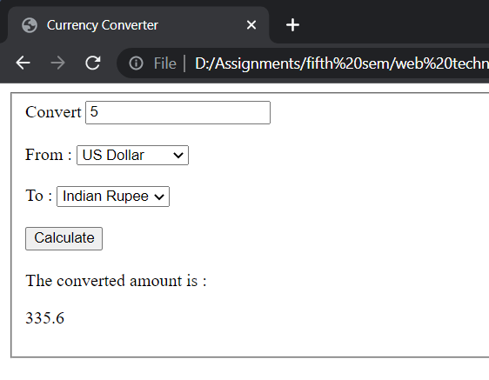

5. Write JavaScript code to randomly change the src of the img in the HTML snippet to “heads.jpg” or “tails.jpg” when the “Flip!” button is pressed.

**Code:**

<!DOCTYPE html>

<html>

    <head>

        <title>Coin Flip</title>

    </head>

    <body>

        <h1>Heads or Tails</h1>

        <div>

            <img src="head.jpg" id ="coin">

            <button type="button" id="flip" onclick="flip()">Flip!</button>

        </div>

        <p>

        Heads Total: <span id="num_head">0</span><br>

        Tail Total: <span id="num_tail">0</span>

    </p>

        <script>

            function flip()

            {

                var img = document.getElementById('coin');

                var head = document.getElementById('num_head');

                var tail = document.getElementById('num_tail');

                var h = parseInt(head.innerHTML);

                var t = parseInt(tail.innerHTML);

                var l = ["head.jpg","tail.jpg"];

                var s = Math.floor(Math.random()*2);

                if (l[s]==l[0])

                {

                    head.innerHTML = h+1;

                }

                else{

                    tail.innerHTML = t+1;

                };

                img.src ="img/"+l[s];

            }

        </script>

    </body>

</html>

**Output:**

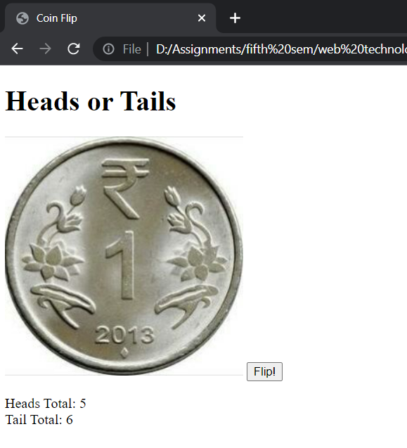

6.Birthday Cake order form with additional tax and tips.

**Code:**

<!DOCTYPE html>

<html>

    <head>

        <Title>Birthday Cake</Title>

    </head>

    <body>

        <h1>Birthday cake Order Form</h1>

        <fieldset>

            #of 1/2kg Cakes : <input type="text" id="small"><br><br>

            #of 1kg Cakes : <input type="text" id="medium"> <br><br>

            #of 2kg Cakes : <input type="text" id="large"><br><br>

            Tip

            <label><input type="radio" value="10" name="tip">10%</label>

            <label><input type="radio" value="15" name="tip" checked = "checked">15%</label>

            <label><input type="radio" value="20" name="tip">20%</label><br>

            <button type="button" id="submit" onclick="bill()">Calculate Order</button><br>

          <span id="price"></span>

        </fieldset>

        <script>

            function bill()

            {

                var half = parseInt(document.getElementById("small").value);

                var one = parseInt(document.getElementById("medium").value);

                var two = parseInt(document.getElementById("large").value);

                var total;

                var small = 100;

                var medium = 200;

                var large = 400;

                total = (half * small) + (one * medium) + (two * large);

                var tax = 0.09 * total;

                total +=tax;

                var tip_per = document.querySelector('input[name="tip"]:checked').value;

                tip=(tip_per/100)*total;

                total += tip;

                document.getElementById("price").innerHTML = "Cost of Order : "+ total +"Rupees";

            }

        </script>

    </body>

</html>

**Output:**

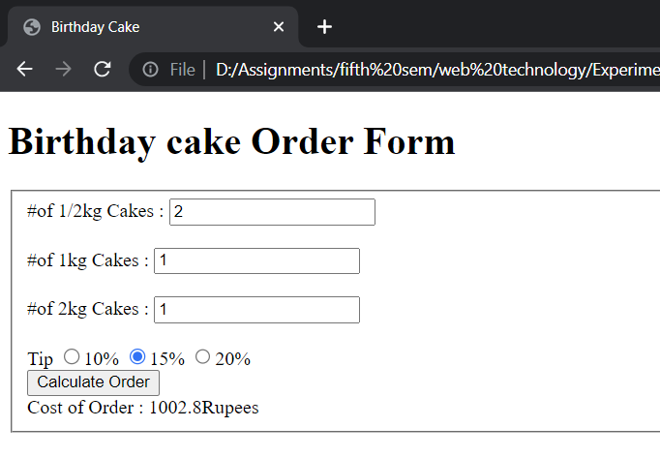

# Result:

The website has been successfully created using JavaScript DOM elements and events.